**Quick Guide to Setting Up Your Account**   
   
To Register/create your account to access and enjoy the Bulkupdate portal viz <http://idcrjil.ril.com/bulkupdate> , if that is the case, you may need to send an email with your reporting manager approval to [rjilidcservicedesk@ril.com](mailto:rjilidcservicedesk@ril.com) then after creation of a ticket within 24 hours your account will be activate for use. Along with you request email share the table name with table level operation to grant access privileges.

Have Fun! If you need help, please contact RJIL Service Desk at rjilidcservicedesk@ril.com or 022-244-50515.

1. Enter URL **www.idc.rjil.ril.com/bulkupdat**e in browser (Firefox, Google chrome recommended )
2. Enter your **user name** ( AD USERNAME of RIL DOMAIN)
3. Eater your **password** ( AD PASSWORD of RIL DOMAIN )
4. Click Login button

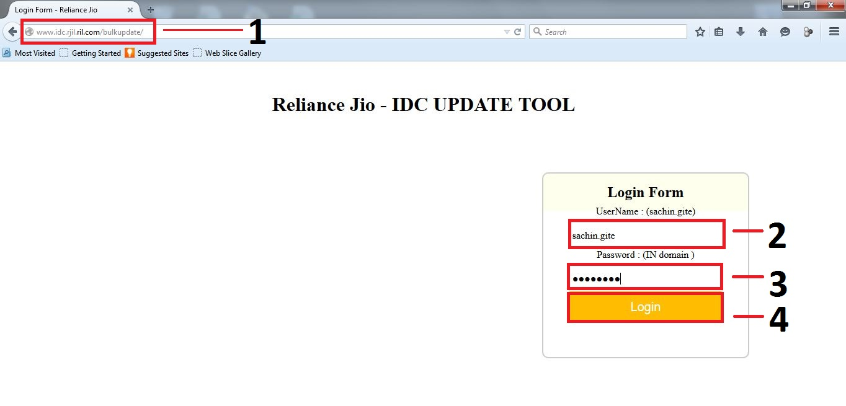

1. Your login user name
2. For exit press on Logout
3. 1. File update, file insert, IGF update is container see depend on user login privilege

2. For Update file, Insert new record, update file in IGF formats click on Browse for Upload file.

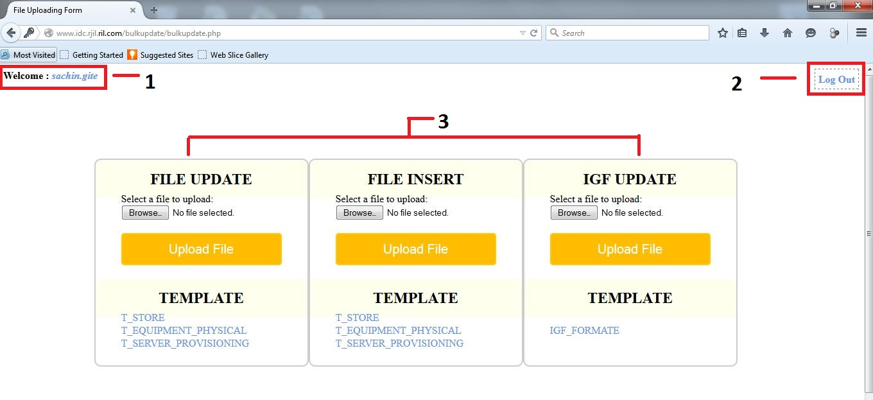

1. Click on Browse Button for file upload
2. On display windows path will open
3. Go to your File location and select .csv file.
4. Click open for upload

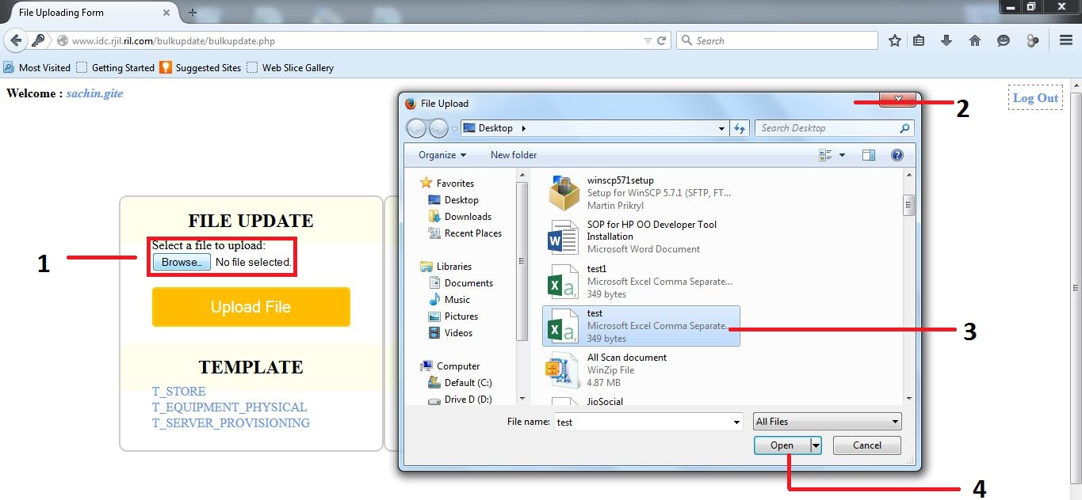

1. Your selected filename will display
2. Click upload file button to upload your csv

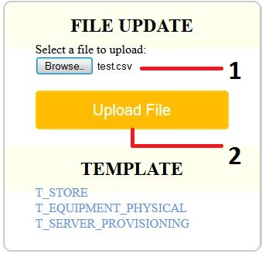

1. Check & verify your column which uploaded value by you
2. If it is ok click on commit button
3. If you want to modify than click on Back button for upload modify csv again.

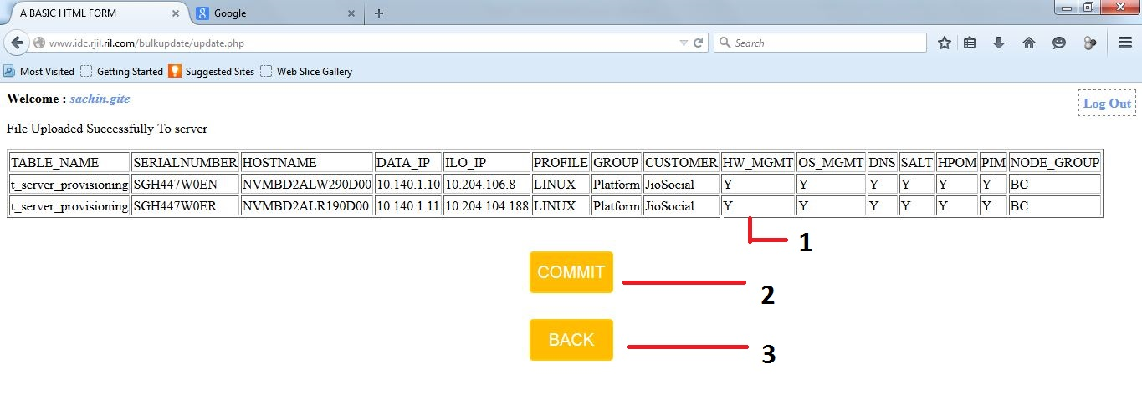

1. After press commit button this output will show database update successfully with update status.

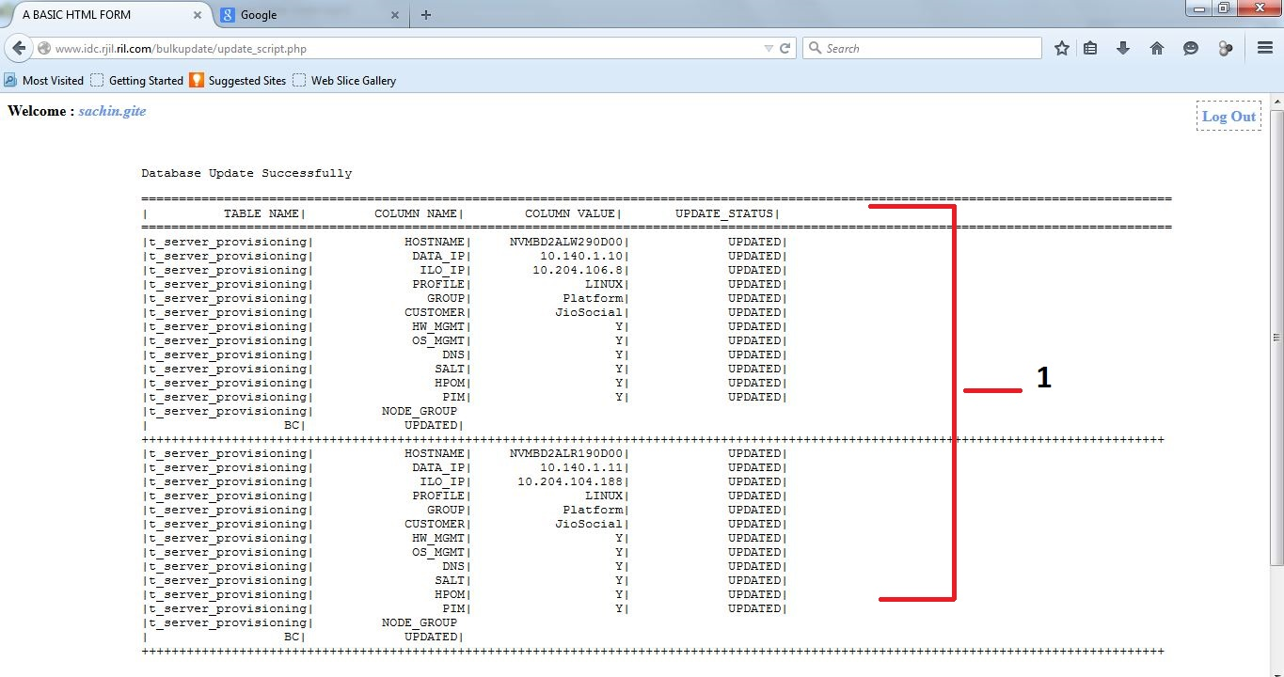

1. If you don’t have permission for update to table Update status show Not authorised

